
nwjLFk f'k{kk funs'kky;
yfyr ukjk;.k fefFkyk fo'ofo|ky;] dkes'ojuxj] njHkaxk & 846 004 (fcgkj)
iQksu ,oa iQSDl % 06272 & 246506] osclkbZV % ddelnmu.ac.in, bZ&esy% director@ddelnmu.ac.in

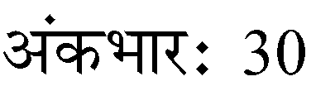
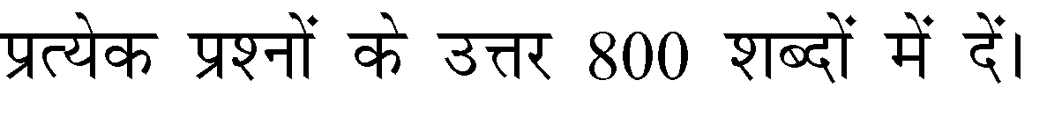
Assignment for BA English (Part III)
%
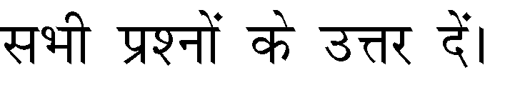

Paper 5
- Discuss briefly the characteristic features of the 19th Century Criticism.
- Analyse T. S. Eliot's concept of history in his essay Tradition and Individual Talent.
- Gynocriticism is the historical study of women writers as a distinct literary tradition. Discuss.

Paper 6
- Evaluate G M. Hopking as a nature poet.
- What is man versus man conflict in the play Candida ? Discuss.
- Describe the use of darkness both in the books title and as a symbol throughout the text in Heart of Darkness.

Paper 7
- Write the critical summary of the poem "Philosophy'.
- Discuss the view of M. K. Gandhi on Indian Civilization and Culture.
- Write the summary of the story 'Sparrow' by K.A. Abbas.

Paper 8
- Write a brief note on A. G Gardiner as an essayist.
- What is an essay ? What are the relevant points to be kept in mind while writing an essay.
- Critically analyse the novel The Apprentice.

·Assignment (nÙkdk;Z) tek djus dh vafre frfFk 30-06-2022·

